**Pharma Sales Dash Board**

Sales task(1 to4)

https://us1.ca.analytics.ibm.com/bi/?perspective=dashboard&pathRef=.my_folders%2FIBM%2BDESH%2BBOARD%2BASSIGNMENT&action=view&mode=dashboard&subView=model000001836eb3435d_00000002

Inventory (Task 5to 8):-

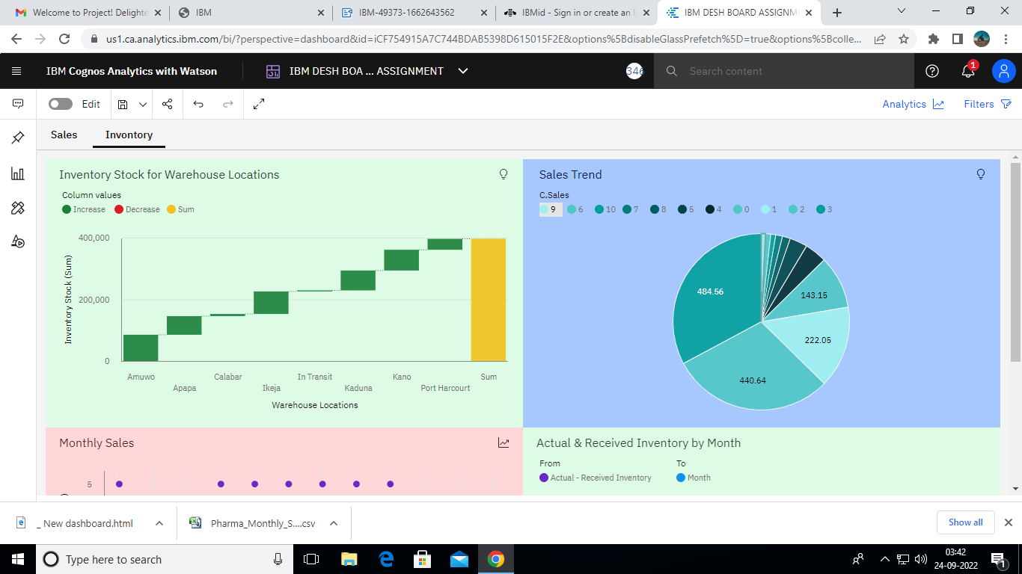

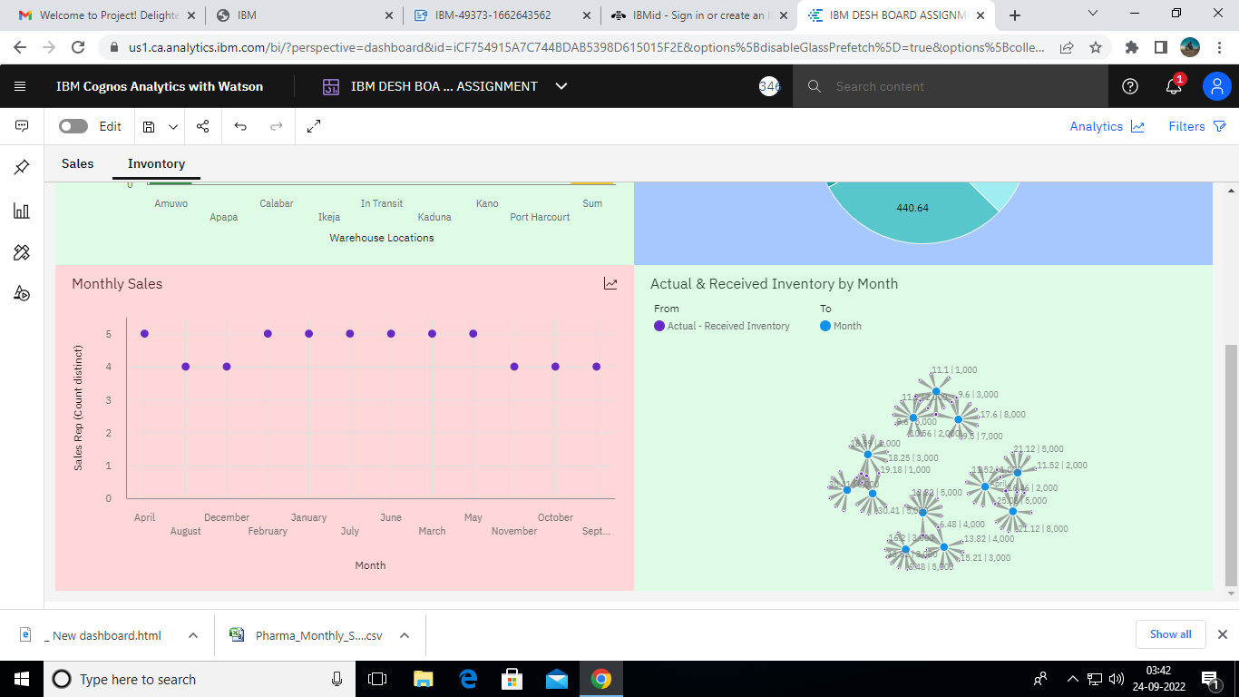

https://us1.ca.analytics.ibm.com/bi/?perspective=dashboard&pathRef=.my_folders%2FIBM%2BDESH%2BBOARD%2BASSIGNMENT&action=view&mode=dashboard&subView=model000001836eb7f030_00000000